|  |  |
| --- | --- |
| **This** | **Or This** |
| C:\Users\Mike\AppData\Local\Microsoft\Windows\Temporary Internet Files\Content.IE5\2ONJA0BC\MP900446464[1].jpg | C:\Users\Mike\AppData\Local\Microsoft\Windows\Temporary Internet Files\Content.IE5\SSI8AT5O\MP900427658[1].jpg |

**The Neura-Learning Solution**

|  |
| --- |
| ***A New On-Line Learning Tool*** |
| ***Take any course and turn it into an on line experience.*** |
| * + Questions designed to solicit understanding – not just memorization |
| * + Quantified response to every question except open ended questions   + Open ended responses are automatically categorized and displayed by question, category, subject and key word |
| * + All questions are automatically scored |
| * + Multiple choice questions are scored and ranked to display level of understanding |
| * + Participants are automatically ranked |
| * + Scores are immediately available to the participants and the organization |
| * + Automatically prioritize actions to be taken |
| ***Including breakthrough behaviors*** |
| * + Each individual analysis may include a narrative on how to best prepare for that specific subject |
| ***Offers each participant the security that his/her answers are anonymous to anyone but him/her and the instructor*** |
| * + Each participant is issued a Student ID that is unique   + No peer pressure |
| ***Anonymously benchmark each participant against peers*** |
| * + Participants are categorized by multiple selectable demographics |
| * + Course designers determine demographics set |
| * + participants choose their individual demographics   + participants learn from each other |
| ***Course does not have to be completed in one sitting*** |
| * + Participant may return as many times as is necessary |
| * + Answers are not recorded until final action is taken |

***This is a formal comprehensive rigorous representation of any course you choose to implement. It offers an additional course opportunity that allows the participant to benchmark their performance anonymously against the other participants***

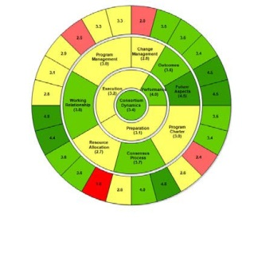

NeuraMetrics helps organizations improve all aspects of their business processes. This application provides accurate, easy to read, real-time data to enable a deep understanding of course materials. Use of this tool drives and improves the grasp of subject matter. It offers the course material in a personalized and interactive presentation that fosters learning.

The NeuraMetrics Learning Tool is an online tool based on the NeuraMetrics Learning Methodology. It will allow each participant to **self-assess** their courseperformance and then help them implement practical changes that reflect course material by **Anonymously** comparing themselves to other participants that scored higher in specific areas.